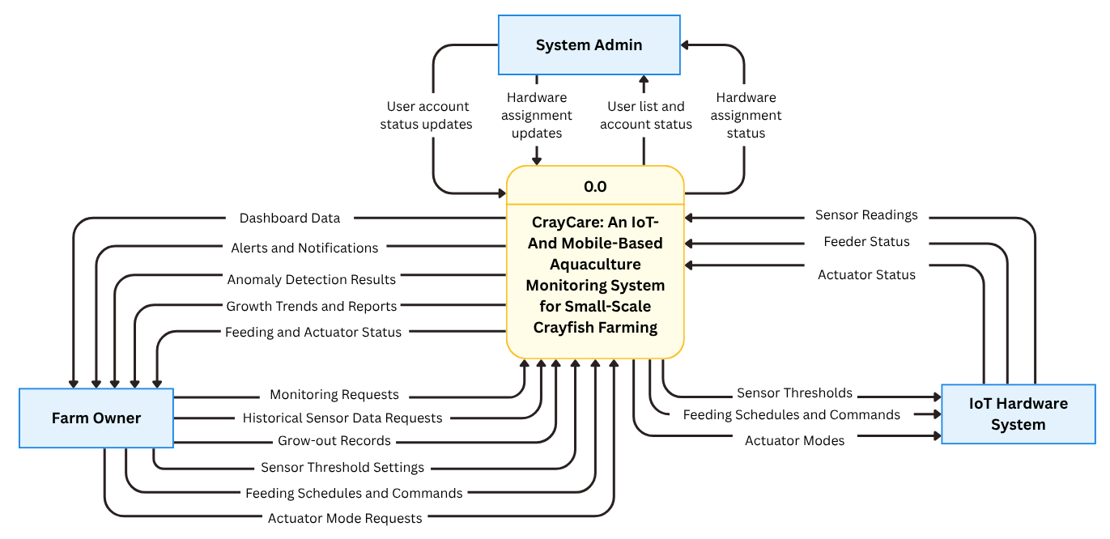Figure 1.2. Level 0 Data Flow Diagram (DFD) of the CrayCare System
Figure 1.2 shows the Level 0 Data Flow Diagram of CrayCare. It presents the overall data flow between the system and its three external entities: the Farm Owner, IoT Hardware System, and System Admin. The Farm Owner sends monitoring requests, historical sensor data requests, grow-out records, sensor threshold settings, feeding schedules and commands, and actuator-mode requests. In return, CrayCare provides dashboard data, alerts and notifications, anomaly detection results, growth trends and reports, and feeding and actuator status.
The IoT Hardware System sends sensor readings, including water-quality, water-level, and feed-level readings, as well as feeder and actuator status. CrayCare sends sensor thresholds, feeding schedules and commands, and actuator modes to the hardware system. The System Admin manages user account status and hardware assignment by linking or unlinking the IoT Hardware System to an authorized Farm Owner and the owner’s tank. The system then provides the user list, account status, and current hardware-assignment status.
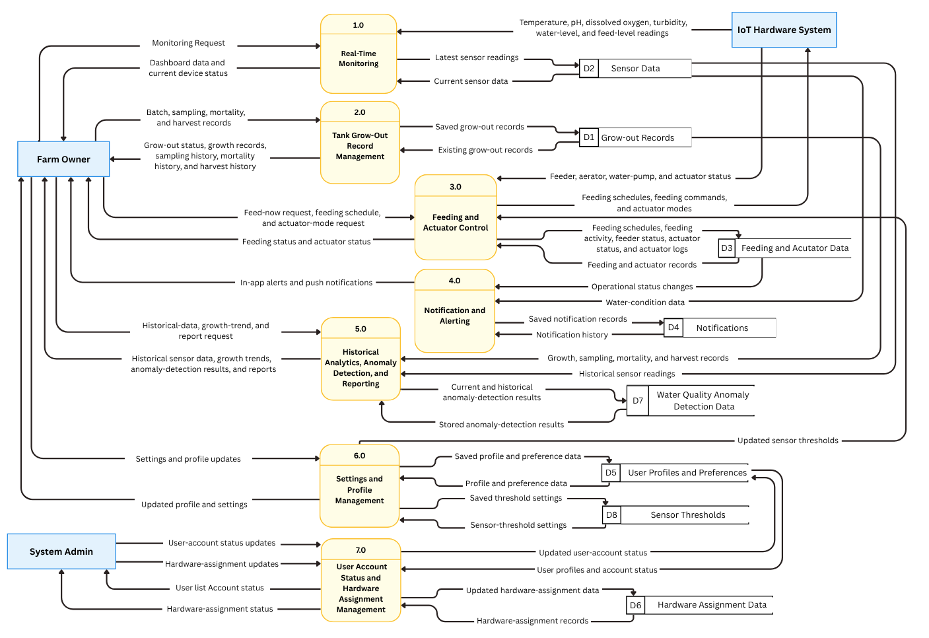Figure 1.3. Level 1 Data Flow Diagram (DFD) of the CrayCare System
Figure 1.3 presents the Level 1 Data Flow Diagram of CrayCare. The diagram decomposes the system into three external entities, seven internal processes, and eight data stores. It illustrates how sensor readings, user requests, control commands, monitoring results, records, notifications, and system settings are exchanged and processed within CrayCare.
The three external entities are the Farm Owner, IoT Hardware System, and System Admin. The Farm Owner sends monitoring requests, batch, sampling, mortality, and harvest records, feeding requests, actuator-mode requests, historical-data requests, and settings updates. The IoT Hardware System provides temperature, pH, dissolved-oxygen, turbidity, water-level, and feed-level readings, together with feeder and actuator status. The System Admin sends user-account status updates and hardware-assignment updates and receives the user list, account status, and hardware-assignment status.
Process 1.0, Real-Time Monitoring, receives sensor readings from the IoT Hardware System, stores the latest readings in D2 Sensor Data, and retrieves current sensor data for display on the dashboard. Process 2.0, Tank Grow-Out Record Management, handles batch, sampling, mortality, and harvest records and stores them in D1 Grow-Out Records. Process 3.0, Feeding and Actuator Control, handles feed-now requests, feeding schedules, and actuator-mode requests. It checks current sensor readings against configured thresholds before feeding, sends feeding commands and actuator modes to the IoT Hardware System, receives feeder and actuator status, and stores feeding and actuator records in D3 Feeding and Actuator Data.
Process 4.0, Notification and Alerting, evaluates water-condition readings against configured sensor thresholds and monitors operational-status changes to generate in-app alerts and push notifications for the Farm Owner; push delivery follows the owner’s notification preferences. It stores notification records in D4 Notifications and retrieves notification history when needed. Process 5.0, Historical Analytics, Anomaly Detection, and Reporting, uses historical sensor readings and growth-related records to provide historical data, growth trends, anomaly-detection results, and reports. The process stores current and historical water-quality anomaly results in D7 Water Quality Anomaly Detection Data.
Process 6.0, Settings and Profile Management, handles the Farm Owner’s profile, notification preferences, and sensor-threshold updates. Profile and preference information is stored in D5 User Profiles and Preferences. Sensor-threshold settings are stored in D8 Sensor Thresholds. Feeding-safety checks and alerting use those thresholds, and the IoT Hardware System reads them. Process 7.0, User Account Status and Hardware Assignment Management, allows the System Admin to update account status and link or unlink the IoT Hardware System to an authorized Farm Owner and the owner’s tank. It uses D5 for user-account information and D6 Hardware Assignment Data for the current hardware assignment.

